Task 1

**Phase 1**

1. The game I choose to create is Fruit ninja. Fruit ninja is a game that its core plot is to slice fruit that is shot from the bottom or sides of the screen. It is a simple game but can be very fun to play. I found a Tutorial on YouTube on how to create a basic fruit ninja game. The video shows how the basics of the game is. The YouTuber is Brackeys and the link to the video: <https://www.youtube.com/watch?v=3g5_8sE18tQ>

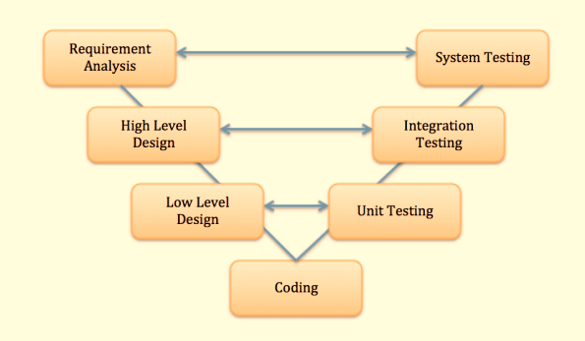

I used the V-Shaped model to as my software development model, because for every thing that was done before continuing testing would be done while code is being implemented

1. These are some of the components that the game will have for sure:

|  |  |
| --- | --- |
| **Blade** | |
| **Properties** | |
| minCuttingVelocity | takes the minmumim speed needed to activate the circle collider |
| **methods** | |
| Startcutting() | This will start the circle collider. |
| Stopcutting() | This will stop the circle collider. |
| Updatecut() | Checks the previous position of the last blade click. |
| OnTriggerEnter2D() | Depending on what the circle collider hits fruit it will give a point. |

|  |  |
| --- | --- |
| **FruitSpawner** | |
| **methods** | |
| SpawnFruit() | Randomly spawning the fruit |

|  |  |
| --- | --- |
| **BombSpawner** | |
| **methods** | |
| Randomly spawning the bomb | Randomly spawning the bomb |

|  |  |
| --- | --- |
| **Score** | |
| **properties** | |
| ScoreValue | Will take the value of each fruit depending what is sliced |

|  |  |
| --- | --- |
| **Live** | |
| **properties** | |
| LiveValue | Will decrease the live when bomb is hit |

|  |  |
| --- | --- |
| **Bomb** | |
| **properties** | |
| OnTriggerEnter2D | Will decrease the live when bomb is hit |
| OnTriggerEnter2D | Decreases live by one |

|  |  |
| --- | --- |
| **Fruit** | |
| **properties** | |
| OnTriggerEnter2D | Increases point’s by depending the fruit sliced. |